SOWIT Video Series – “All Roads Lead to Rome”
(Video link: www.edb.gov.hk/sowit_Rome2)

Lesson Plan

Suggested Levels
Upper Primary/Junior Secondary
Summary of the Learning Task
Students watch the SOWIT video “All Roads Lead to Rome”, which is about three brothers using different ways to reach an island with abundant resources. Students are then guided to understand the meaning of the saying “All roads lead to Rome”, the related positive values and attitudes (e.g. be positive and optimistic), and share the things they would do to stay positive and optimistic.
Learning Objectives
Content
- To understand the meaning of the saying “All roads lead to Rome.” through a story presented in the context of a video
Language
- To explore the story elements of the video (e.g. characters, setting, problem, solution)
- To learn adjectives that describe feelings
- To express how to stay positive and optimistic using the sentence pattern “To stay positive and optimistic, I would…”
Values and Attitudes
- To cultivate positive values and attitudes (e.g. be positive and optimistic)
Sharing Learning Intentions
1. Introduce the objectives of the learning activities
Pre-viewing
Part A: Making Predictions about the Story Elements
- Refer students to Activity Sheet: Part A.
- Draw students’ attention to the pictures below, which depict the scenes of the SOWIT video “All Roads Lead to Rome”:
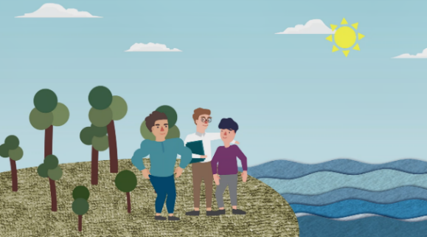

- Guide students to make predictions about the story elements by drawing their attention to the visual clues captured in the pictures (e.g. the differences between the two islands, the reasons why the three brothers wanted to go to the island some distance away).
- Discuss with students their observations.
Viewing
Part B: Understanding the Story Elements
- Refer students to Activity Sheet: Part B.
- Introduce the story elements (i.e. characters, setting, problem, solution) before playing the video and instruct students to note down some key points for each element while watching the video.
- Play the video “All Roads Lead to Rome”.
- Discuss with students the story elements in the video.
Post-viewing
Part C: Characterisation
- Refer students to Activity Sheet: Part C.
- Guide students to understand how the three brothers reached the island using their own ways (e.g. based on their strengths, the three brothers used their own ways to reach the island).
- Guide students to write down the adjectives that describe the feelings of the three brothers when they met one another on the island.
- Draw students’ attention to the fact that the eldest brother was not as strong as the youngest brother nor as knowledgeable as the middle brother. Ask them whether they would envy the youngest and middle brothers if they were the eldest brother. Guide them to understand that everyone has their own strengths, there is no need to envy others, and the best way is the one that suits them most.
- Play the video again whenever necessary.

Part D: Understanding the Saying of Wisdom
- Refer students to Activity Sheet: Part D.
- Ask students to complete Questions 1 & 2.
- Discuss with students the meaning of the saying “All roads lead to Rome.” (i.e. all the methods of doing something will achieve the same result in the end).
- Discuss with students the message conveyed by the story (i.e. we have our own strengths; the best way to do something is the one that suits us most).
- Guide students to understand that it is important to stay positive and optimistic because this helps us find ways to solve our problems.
- Ask students to write down the things they would do to stay positive and optimistic and share them with their classmates.

SOWIT Video Series – “All Roads Lead to Rome”
Activity Sheets
(Pre-viewing)
Part A: Making Predictions about the Story Elements
The pictures below depict the scenes of the SOWIT video “All Roads Lead to Rome”. What do you think the video is about? Answer the following questions.

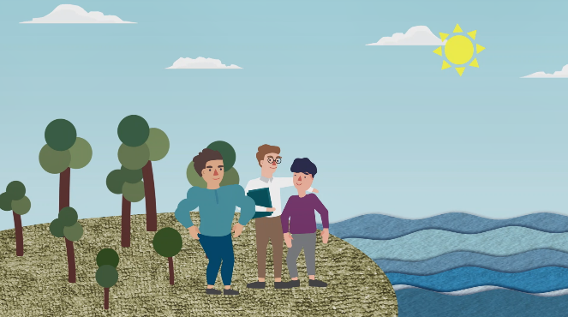

- What were the differences between the two islands?
________________________________________________________________________________________________________________________________________________________

- Why did the three brothers want to go to an island some distance away?
______________________________________________________________________________________________________________________________________________________

- Can you predict how they went there? You may discuss with your classmate(s).
______________________________________________________________________________________________________________________________________________________

(Viewing)
Part B: Understanding the Story Elements
- Watch the video and complete the story elements below.

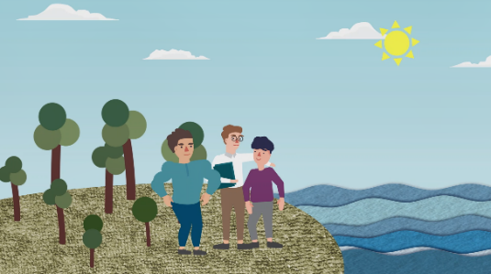
- Who were the characters?
e.g. The three brothers
(b) Where did the story take place?

(c) The three brothers wanted to reach the bigger island. What problem did they have?

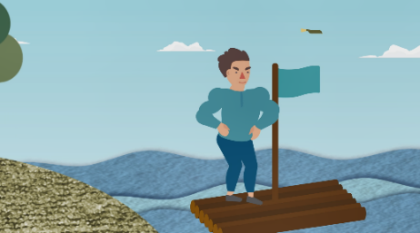
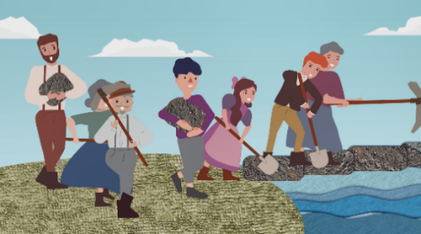

(d) How did the three brothers solve the problem?
The youngest brother:

The middle brother:

The eldest brother:

(Post-viewing)
Part C: Characterisation

- The three brothers reached the island one after another. In what ways did each of the brothers reach the island? Why? Complete the text boxes.

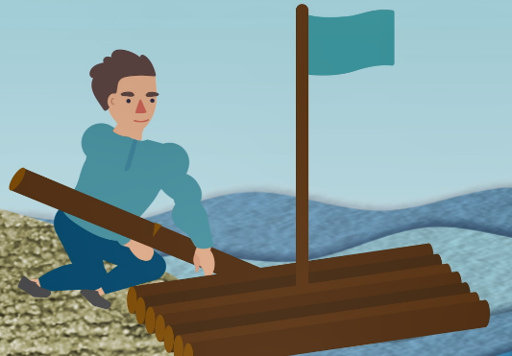
The youngest brother decided to (a) ____________________________ because (b) _____________________ _______________________________.
_______________________________

The middle brother decided to (c) ____________________________ because (d) _____________________ ________________________________.
_______________________________

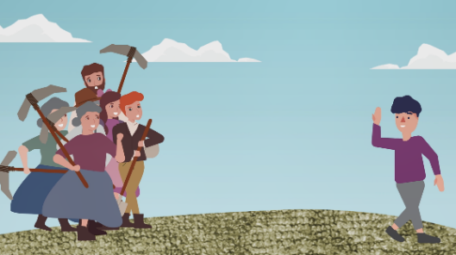
The eldest brother decided to (e) ____________________________ because (f) _____________________ _______________________________.
_______________________________

Based on (g) ___________________________________________, the three brothers used their own ways to reach the island. ______________________________________________

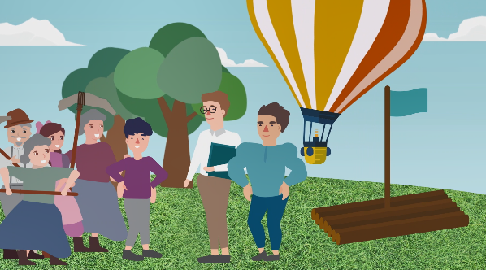
- The three brothers met one another on the island. How did they feel? Write down some adjectives in the space provided to describe their feelings.

- The youngest brother was strong while the middle brother was knowledgeable. If you were the eldest brother, would you envy your brothers? Why?

_________________________________________________________________________________________________________________________________________________________________________________________________________________________________

Part D: Understanding the Saying of Wisdom
Answer the following questions.
- What is the meaning of the saying “All roads lead to Rome”?
________________________________________________________________________________________________________________________________________________
- What is the message conveyed by the story?
________________________________________________________________________________________________________________________________________________

- The three brothers had a big problem. However, they did not give up their goal. Instead, they stayed positive and optimistic and found their own ways to solve the problem. It is important to stay positive and optimistic when you face problems. Write down the things you would do to stay positive and optimistic and share them with your classmates (e.g. “To stay positive and optimistic, I would see challenges as learning opportunities.”)

To stay positive and optimistic, I would …

SOWIT Video Series – “All Roads Lead to Rome”
Activity Sheets (Suggested Answers)
Part A: Making Predictions about the Story Elements
1. | The tiny island on which the three brothers grew up was barren and the trees were small and weak./The trees on the bigger island were thriving and the soil was fertile.
2. | There were abundant natural resources (e.g. grains, fruits, vegetables) on the bigger island.
3. | They might go to the island by boat/raft.
(Accept any reasonable answers.)

Part B: Understanding the Story Elements
1. | (a)  (b) | The three brothers (given)  The story took place on a tiny island.
 | (c) | The three brothers had to find ways to cross the sea in order to reach the bigger island.
 | (d) | The youngest brother chopped down some trees, built a raft and set sail for the island.
 |  | The middle brother conducted a lot of research, built a hot air balloon and flew to the island.
 |  | The eldest brother gathered a group of villagers to build a stone bridge to reach the island.
(Accept any reasonable answers.)

Part C: Characterisation
1. | (a) build a raft; (b) he was muscular
 | (c) build a hot air balloon; (d) he liked conducting research and making things
(e) build a stone bridge; (f) he was friendly and he could gather a group of villagers
to work together
 | (g) their strengths
2. | happy joyful excited cheerful delighted contented overjoyed  (Accept any reasonable answers.)
3. Accept any reasonable answers.

Part D: Understanding the Saying of Wisdom
1. | All the methods of doing something will achieve the same result in the end.  (Accept any reasonable answers.)
2. | Everyone has their own strengths and all the methods of doing something will achieve the same result in the end. The best way is the one that suits them most.  (Accept any reasonable answers.)
3. | Accept any reasonable answers.

